**Constraint Effective Potential in a 5D Gauge-Higgs Unification Model**

**Project ID or Acronym:** *HWU24*

**HPC system(s):** JURECA/*JUWELS*

**Principal investigator: *Roman Höllwieser***

*Phone: 0202 439 3439, e-mail: hoellwieser@uni-wuppertal.de,*

*Fakultät für Mathematik und Naturwissenschaften*

*Bergische Universität Wuppertal, Gaußstr. 20, D-42119 Wuppertal*

**Project contributor(s): *Michael Guenther*** *and* ***Francesco Knechtli***

*Fakultät für Mathematik und Naturwissenschaften*

*Bergische Universität Wuppertal, Gaußstr. 20, D-42119 Wuppertal*

***Nikos Irges***

*Department of Physics School of Applied Mathematical and Physical Sciences, National Technical University of Athens Zografou Campus,*

*GR-15780 Athens, Greece*

**Abstract:**

The Higgs particle is a fundamental particle in physics that plays a crucial role in our understanding of the universe. It was discovered in 2012 at the Large Hadron Collider (LHC) and is associated with the Brout-Englert-Higgs (BEH) mechanism, which explains how elementary particles acquire mass. The Higgs particle is closely linked to gauge-Higgs unification models, which propose a unification of the electromagnetic and weak forces in the context of extra space dimension(s). The Higgs potential is a mathematical expression that describes the self-interactions of the Higgs field and helps us understand the behavior of particles. We developed an efficient algorithm to simulate gauge-Higgs models in order to measure this potential with very high accuracy.

**Report:**

The discovery of the Higgs particle in 2012 at the Large Hadron Collider (LHC) marked a major milestone in particle physics. This elusive particle, also known as the Higgs boson, is a fundamental particle that provides valuable insights into the nature of the universe. The Higgs particle is associated with the Brout-Englert-Higgs (BEH) mechanism, which explains how elementary particles acquire mass via interaction with the Higgs field, which is permeating space-time. Imagine particles moving through a room filled with a substance that slows them down, similar to how a swimmer experiences resistance in water. This interaction with the Higgs field gives particles their masses, making them heavier or lighter. Resonances of this field are measured in particle detectors as Higgs particles.

The Higgs particle and the BEH mechanism are linked to gauge-Higgs unification models, which propose a grand unification of the electromagnetic and weak forces, two fundamental forces of nature. In these theories, the Higgs field plays a central role in uniting these forces, providing a common framework to describe their interactions. We simulate a potential candidate of these models on a five-dimensional lattice, discretizing space-time and an extra dimension which carries the degrees of freedom responsible for the Higgs field. To understand the behavior of the Higgs particle and its interactions with other particles, we want to measure the Higgs or Mexican hat potential, describing the energy associated with the Higgs field and its fluctuations. It gets its name due to its shape, which resembles a sombrero or a Mexican hat, see Fig. 1 (left). This potential has a characteristic property that allows for spontaneous symmetry breaking of the electroweak symmetry.

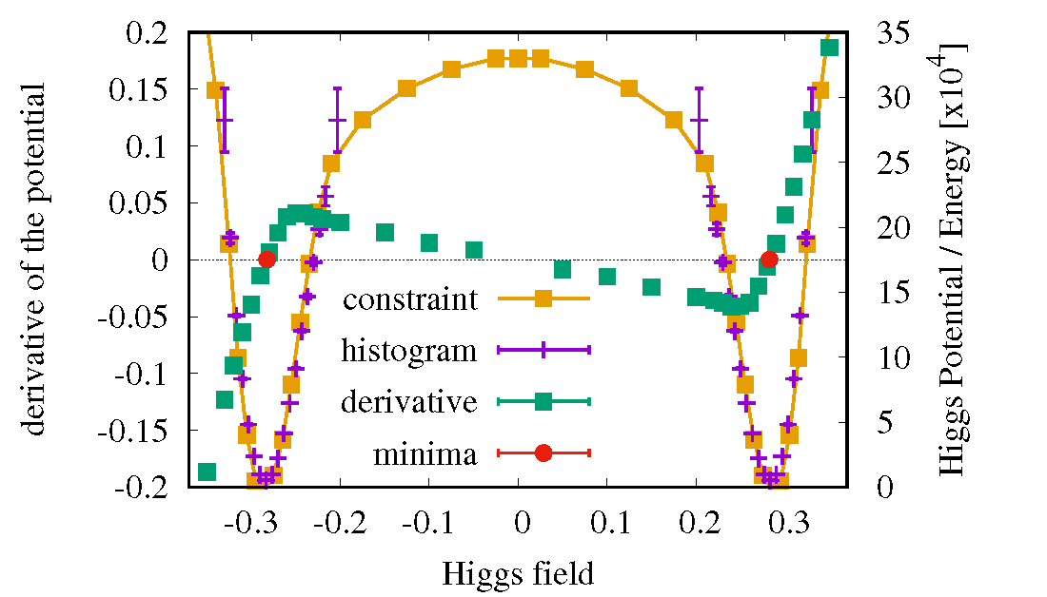

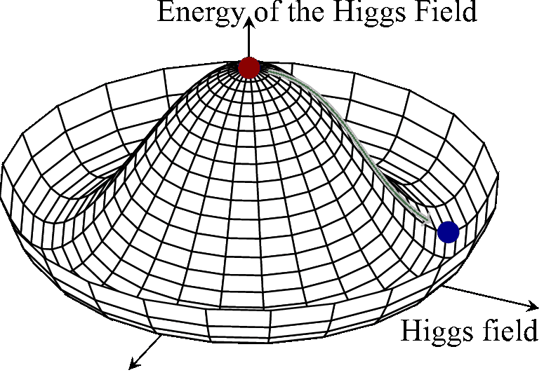

Fig. 1: The Higgs or Mexican hat potential (left). Our measurement of the potential in the context of gauge-Higgs unification, comparing the new (constraint) and old (histogram) method, together with the derivative and minima of the Higgs potential.

Symmetry breaking refers to a situation where the underlying laws of physics possess a symmetry, but the lowest energy (ground or vacuum) state of the system does not exhibit that symmetry. In the case of the Higgs field, the Higgs potential is symmetric at its local maximum, the central peak of the hat (red dot). However, the minimum of the potential corresponds to the brim of the hat. The actual expectation value of the field at the minimum (blue dot) breaks the rotational symmetry of the brim. The interaction of particles with the finite Higgs field causes particles to become massive. The Higgs potential allows scientists to predict the behavior of the Higgs field at different energies and helps them understand the fundamental nature of particles.

During the project, a new method was developed to measure this potential very precisely in so-called ‘constrained’ simulations, where the Higgs field can fluctuate around a fixed expectation value only, which allows to also explore regions far from the potential minima which are not accessible in unconstrained simulations. In the right plot of Fig. 1 the potential measured via the new method (‘constraint’, orange squares) is compared with the potential derived via the traditional method from the distribution of the Higgs field (‘histogram’, purple crosses). The elegance of the new method is that from the actual constraint of the simulations one can measure the derivative of the potential very precisely (green squares in the figure) from which the Higgs potential (orange squares) and its minima (red dots) are computed. The drawback is that the method is computationally more expensive, each green square needs a separate simulation, but the precision of the final result and in particular the otherwise inaccessible regions of the Higgs field, e.g. the maximum of the Higgs potential (tip of the hat), compensate for the effort. In order to measure the constraint potential a modified numerical integration scheme for the Hybrid Monte Carlo algorithm in the presence of a constraint was developed based on the Rattle algorithm. The numerical simulations have been performed at the supercomputers JURECA/JUWELS at the Juelich Supercomputing Centre (JSC). For more detailed information see

[1] R. Höllwieser and F. Knechtli, *Constraint HMC algorithms for gauge-Higgs models*, PoS, LATTICE2018, 052, 2018. <https://arxiv.org/abs/1812.02045>

[2] M. Guenther, R. Höllwieser and F. Knechtli, *Constrained Hybrid Monte Carlo algorithms for gauge-Higgs models*, Comput. Phys. Commun., 254, 107192, 2020. <https://arxiv.org/abs/1908.10950>